1..hostname -----To display the name of the host

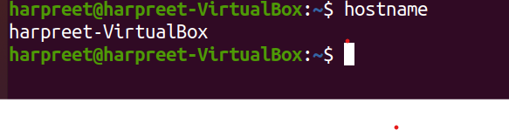

2..whoami----To display the username

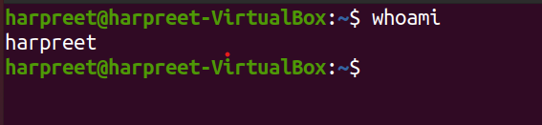

3.ls ------

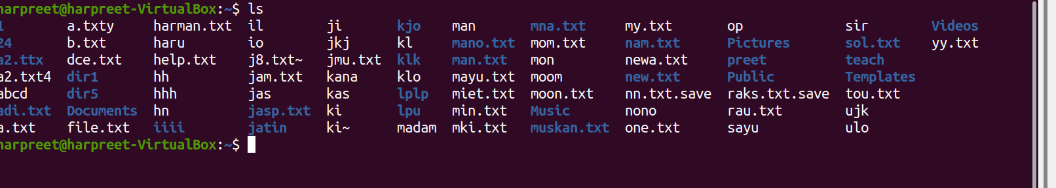

4.ls-al------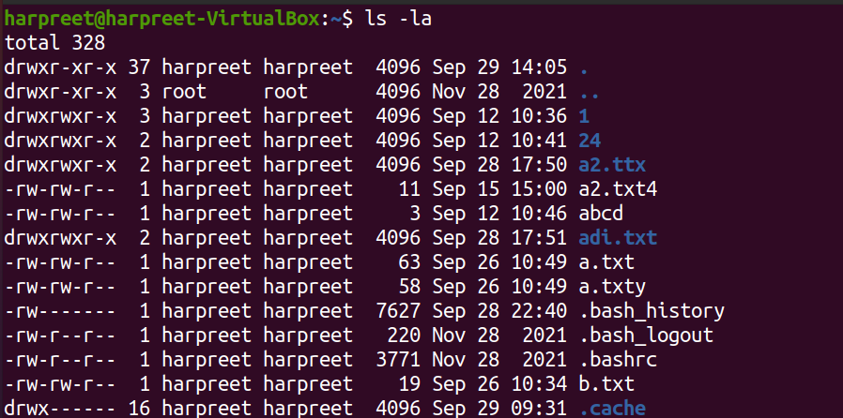

5.pwd ----To see the present directory

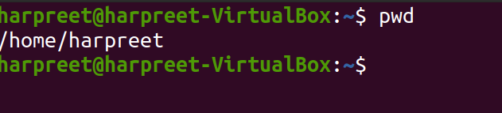

6.cd--- To go to home directory

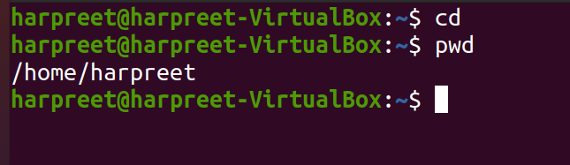

7.touch --- to create a new file

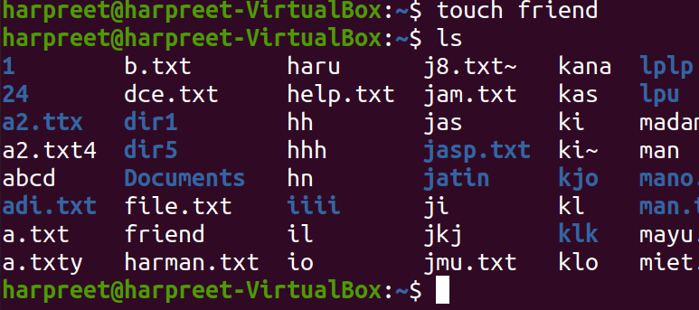

8.vi/nano

